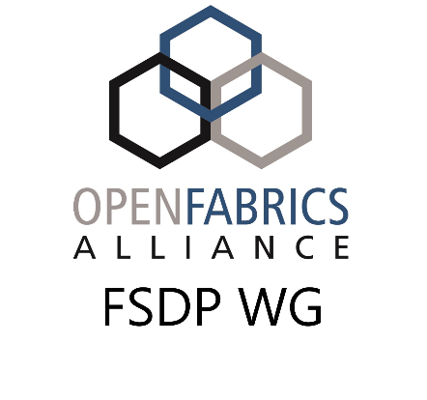
Fabric Software Development Platform
Account Creation Request Form

Name: ______________________________________________
E-Mail: ______________________________________________
Account Type: __ Individual __ Company
Company Name: ______________________________________________
Requested Username: ______________________________________________

UNH-IOL Use Only:
Actual Username (if different): ______________________________________________
Assigned Company Group: ______________________________________________
Assigned Temporary Password: ______________________________________________

Instructions:
- Users should fill out all requested fields. The company name should be a company with a valid account at the OFA, or may be blank if this is an Individual account request.
- Users should email this file their ssh public key they wish to have placed into the system to: fsdp-accounts@openfabrics.org
- Once approved, the user request will be forwarded from the OFA to UNH-IOL for fulfillment
- Once the account is created, the user will be emailed to notify them of their account, given their temporary password, and also given an OpenVPN profile to access the cluster
- The user will need to access the cluster the first time using the OpenVPN profile and temporary password, then login to build-00.ofa.iol.unh.edu as themselves. The system will require they immediately change their password. Once their password is changed, all further access, including future logins to the OpenVPN server, will require the new password.
- At this point the user will have full access to the FSDP cluster.

