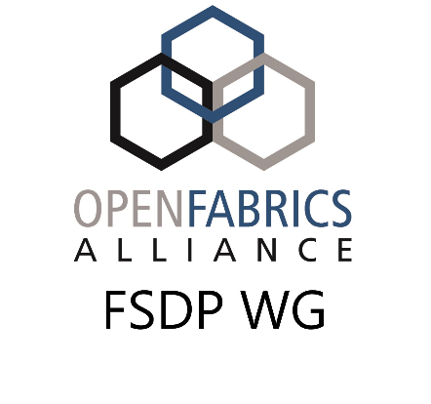
Fabric Software Development Platform
Account Deletion Request Form

Requested Action: ___ Delete ___ Suspend ___ Archive Account(s)
Specific Account: ______________________________________________
Or
All accounts belonging to: ______________________________________________
Archive Recipient: ______________________________________________

UNH-IOL Use Only:
Account(s) acted on: ______________________________________________
Archive transferred to: ______________________________________________
Date completed: ______________________________________________

Account actions are:
- Delete – permanently remove account and user’s home directory without any attempt to save home directory contents
- Suspend – temporarily suspend accounts, preventing access to cluster, but leaving all user data intact
- Archive – permanently remove account and user’s home directory, but tar up home directory and transfer tar archive to archive recipient
Action can be performed either on a specific account, or an entire organization.
Archive recipient should either be an account on the FSDP, in which case the tar archive will be copied to their home directory, or an email address of someone that can arrange for transfer of the archive file.

