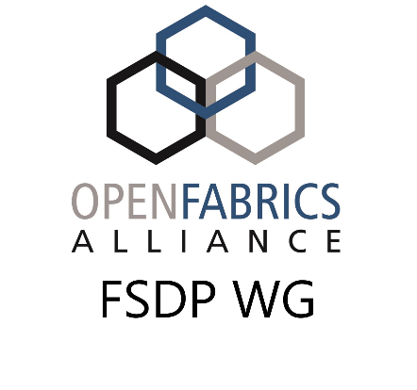
Fabric Software Development Platform
Account Creation Request Form
ACCESS TO THE FSDP CLUSTER IS SUBJECT TO THE ACCEPTABLE USE POLICY. THE FSDP CLUSTER IS OPERATED ON A BEST EFFORT BASIS. NO GUARANTEE OF UPTIME OR ANY OTHER WARRANTY, EXPRESS OR IMPLIED, IS MADE.
Name: ______________________________________________
E-Mail: ______________________________________________
Account Type: ___ Individual ___ Company
Company Name: ______________________________________________
Requested Username: ______________________________________________

UNH-IOL Use Only:
Actual Username (if different): ______________________________________________
Assigned Company Group: ______________________________________________
Assigned Temporary Password: ______________________________________________

Instructions:
- Users should fill out all requested fields. The company name should be blank if this is an individual account, otherwise it must be an organization that is a member of the OFA in good standing.
- Users should email this file and an ssh public key they wish to have placed into the system to: fsdp-accounts@openfabrics.org
- Upon account creation, this form, fully filled out, will be returned along with an OpenVPN profile to access the cluster
- The user will need to access the cluster the first time using the OpenVPN profile and temporary password. They should immediately login to build-00.ofa.iol.unh.edu. The system will require they change their password. Once the password is changed, all further access, including future logins to the OpenVPN server, will require the new password.

