**OpenFabrics Management Framework**

The OpenFabrics Management Framework is in development to provide a common framework that helps to simplify the development of network fabric management applications and tools.

**Why?**

With exciting new advancements in technologies developed for HPC and Cloud computing systems, there are new diverse methods for designing and implementing both shared memory and remote IO storage.

Shared memory accessible by CPU cores, both on the same server and shared across networks are important in application design and operation. Also, the Amdahl number law states that a processor will need some IO per second when there is a number of instructions performed per second. In Amdahl’s IOPS Ratio law, programs are expected to need to do I/O every 50,000 CPU instructions.

New heterogeneous and diverse high-speed fabrics are being designed to allow application access to both shared memory and IO storage. Some of these high-speeds are being designed to be optimized to provide low-latency memory operations. Other network designs are being optimized to provide high bandwidth.

Currently, no common framework and toolset exists for coordinating, arranging, and composing such things as high-speed network Fabric Attached Memory, Non-volatile Memory, concurrent multiple network fabrics, and at the same time, while providing applications and users a common security toolkit.

**Who?**

The OpenFabrics Management Framework is designed to provide System Administrators, Application Programmers and users, HPC and Cloud Architecture Designers, and other stakeholders that are involved in the design and deployment of stable and high-speed network based computing systems.

**How?**

The OpenFabrics Management Framework (OFMF) provides a universal set of tools and services to manage attached fabrics. The OFMF uses a common language, Redfish, to allow clients to manipulate network fabrics and request information about the fabrics. Each vendor type of fabric can be controlled and manipulated through the use of a custom fabric-attached agent that is designed to provide its services and functions to the OFMF.

R

E

D

F

I

S

H

The OpenFabrics Management Framework (OFMF) is designed to be versatile and allow clients to connect and interact with underlying high-speed fabrics.

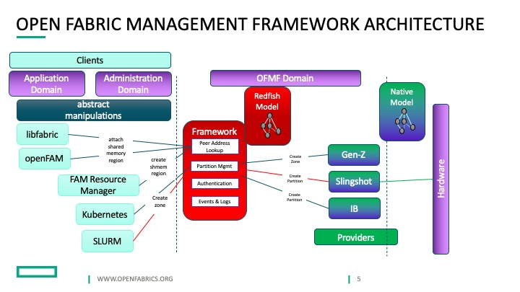

In the diagram above, clients that interact with the OFMF can include libfabric, Kubernetes, Slurm, and myriad other types of clients that might utilize or monitor fabric services. The advantage of a centralized framework is that there is a uniform set of tools that the clients can access to gain insights and manipulate underlying fabrics.

The OFMF provides tools that interact with [Redfish](https://www.dmtf.org/standards/redfish) and [Swordfish](https://www.snia.org/forums/smi/swordfish). Redfish and Swordfish provide both a database and a set of methods to create a virtual mirror image of a physical set of fabrics. It should be noted here that the OFMF can integrate, manipulate, monitor, and control multiple, simultaneous fabrics, at the same time. In addition, the OFMF is being designed to pick optimum options for fabrics.

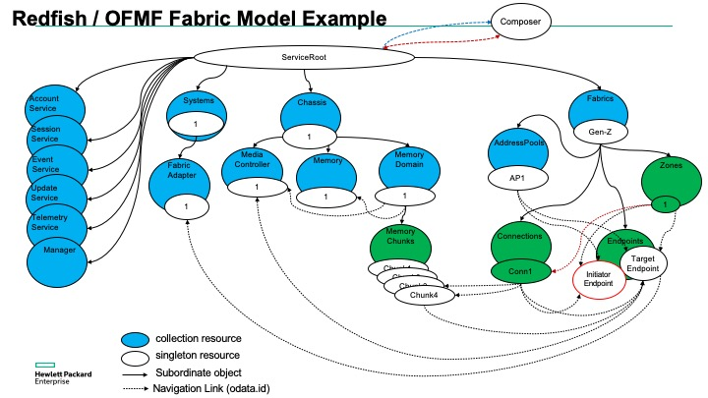

A fabric model in the ‘Redfish domain’ can be modeled as a group of endpoints, resources, zones, and zones-of-zones. An endpoint can be considered to be a destination, such as, a server connected by a network card or a switch port. A resource can be considered as a component that provides services to a fabric. A zone can be considered to be a unit, a set, of endpoints and resources that provide an integrated unit, such as a set of remote memory. Finally, a zone-of-zones can be considered to be a unit, or collection, of zones.

In the Redfish model, there is no nature of physical separation. Thus, a zone of memory, for instance, could be made up of 2 separate fabrics that are routable to each other, yet are not located in the same set of endpoints.



**Use-Case descriptions** 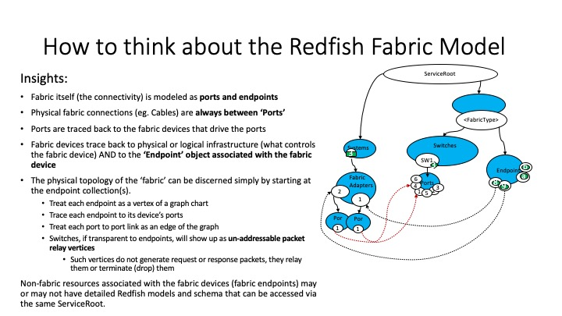

**Use-Case descriptions**

[Create a Connection to Fabric Attached Memory](https://downloads.openfabrics.org/WorkGroups/ofmfwg/use_cases/Create_a_Connection_Use_Case_Description_v2_rwh_012221.docx)

* In this Use Case, a client requests a fabric endpoint connection between a server and Fabric Attached Memory (FAM) with read/write permissions, no fabric encryption, while picking the connection with the lowest latency, highest bandwidth, and at least one redundant path in active/active mode.

Endpoint

Zone

Chunks

[K8s Cluster Create a Zone Use Case Description](https://downloads.openfabrics.org/WorkGroups/ofmfwg/use_cases/K8s_cluster_Create_a_Zone_Use_Case_Description.docx)

* In this Use Case, use a Redfish Composition to allocate a zone object to define a virtual, private network within a larger fabric.

[Slurm Allocate a Batch Use Case Description](https://downloads.openfabrics.org/WorkGroups/ofmfwg/use_cases/Slurm_Batch_Use_Case_Description.docx)

* In this Use Case, use a Redfish Composition to interact with Slurm to define a zone of nodes within a larger fabric

Cluster Log-in

Zone

Chunks

[Create a Fabric Attached Memory Block](https://downloads.openfabrics.org/WorkGroups/ofmfwg/use_cases/Use_Case_Description_Attach_Fabric_Attached_Memory_Block.docx)

* Provide a memory attached block

Chunks

Endpoint

**Proof-of-Concept using the Gen-Z fabric**

In partnership with the [Gen-Z Consortium](https://genzconsortium.org/), the [OpenFabrics Alliance](https://www.openfabrics.org/), the [DMTF](https://www.dmtf.org/about), and the Storage Network Industry Association [(SNIA)](https://www.snia.org/)  are planning to demonstrate key features of the new OFMF at the upcoming [SC21](https://sc21.supercomputing.org/) Supercomputing Conference in St. Louis, Missouri.

The purpose of the proof-of-concept will be to allow a user to interface with a GUI to reach across a Gen-Z fabric and assemble combinations of Fabric Attached Memory. The OFMF provides tools that interact with clients and the fabric. The clients consist of a User, a Fabric Attached Memory Manager, and a Composition Manager.

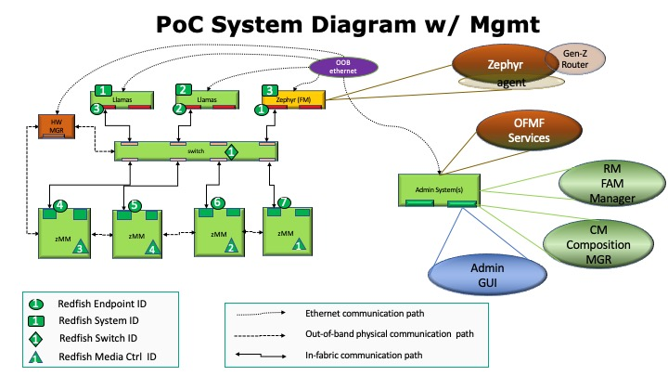

The Gen-Z Subnet Manager, Zephyr, will be responsible for initiating fabric endpoints, switches, and switch ports for the underlying high-speed fabric. On the left side of the diagram, the fabric can be seen as a Redfish logical representation. Each memory module is connected by a cable to a switch port.

Ongoing work is being performed at: <https://github.com/OFMFWG>



