Open Fabrics Management Framework
Document Outline
Table of Contents
2 Overview 3
3 Architecture of the OpenFabrics Management Framework 3
4 OFM Fabric Agents 5
5 Resources Configuration 5
6 Fabric Configuration 5
7 Authentication and access control 5
8 Systems composability 6
9 Events and logs 6
10 Security 6
11 Use cases 7

Overview
- Provide universal orchestration and management tools for computational resources and clients
- Provide a central Redfish/Swordfish database for abstractly associating edges (fabrics links) to nodes (clients and resources)
- One set of abstract tools for all compute fabrics
  - In current HPC and Cloud system management, controlling compute fabrics requires a different set of options and control knobs depending upon the type of fabric used
  - Future HPC and Cloud system management will benefit from the ability to aggregate and subdivide fabrics regardless of the fabric types

Architecture of the OpenFabrics Management Framework

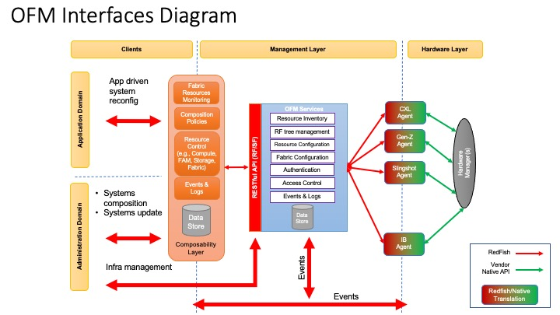

- Clients and Client Applications are placed on the left side of the diagram
  - Clients in the administration domains are considered to be HPC and Cloud system Users, their batch and interactive jobs, System Administrators, and other machine stakeholders
    - ‘Bare metal’ machines
    - Virtual machines and Containers
  - Client in the application domain consist of Batch and Interactive jobs, libraries, monitoring systems, compilers, user environments
- The OpenFabrics Management Framework provides RESTful services, in the middle of the diagram
  - Resource inventory consists of available memory, available processors, available switches, available accelerators, and fabric connections to consolidate and make connections
    - CXL-3.0 compatible resources
      - PCIe-6.x with a peer-to-peer CPU bus addendum
      - Flash memory can be subdivided and associated with CPUs and accelerator cards
      - Peer-to-Peer switching allows for any type of switch topology from Fat-Trees to Rings to Dragon Fly topologies
    - Aggregation of resources under groups
      - A set of resources can be grouped under a set of routes and switches
      - The OFMF will know how to reach each resource and make abstract connections as a client makes resource requests
    - Fabric connections are made abstractly
      - Each fabric connection uses the same set of tools
  - Redfish Tree Management
    - One set of RestFul APIs provides information on connections, clients, and resources
      - Information is provided in the same manner for each resource and connection
    - Aggregation and disaggregation of resources are provided with the same set of tools
  - Fabric and resources configuration
  - Authentication and Access control
    - User authentication
    - Multi-tenancy
  - Events and Logs
    - Flapping connections
    - Adding and removing fabrics
    - Dynamically adding and subtracting fabric connections
  - Systems composability
- Right side of diagram consists of hardware
  - Fabrics and Fabric Managers
    - Ethernet, InfiniBand, Slingshot, OmniPath, CXL-3.0, Gen-Z, etc.
    - Information and control is provided by a Fabric Manager
  - CXL-3.0 compatible hardware
    - CPUs
    - Fabric Attached Memory
    - Accelerator cards

OFM Fabric Agents
- Agents provide an interface from the OpenFabrics Management Framework to the physical hardware
  - Translation is provided from Redfish and Swordfish to physical hardware commands
  - Information on fabrics and resources is translated back to the OpenFabrics Management Framework in real-time
- Agent registration to OFM
  - Define how an agent authenticates with OFM
    - Does it use the regular redfish authentication?
  - Define how the OFM RF tree is populated when a new agent comes up or as a response to an agent event
    - Example: Agent registers using an Event on the Fabrics object and the OFM scans the agent RF tree to populate its own
    - Alternative is the Agent performs a number of POST calls against the

Resources Configuration
- One set of tools to manage Fabric Attached Memory, accelerator cards, CPUs, High-Bandwidth memory

Fabric Configuration
- One common set of tools to provide abstract management of fabric resources
- Fabric links and their capabilities are displayed and managed as disaggregated resources
- How-to connect resources in the fabric

Authentication and access control
- Authentication
  - Redfish/Swordfish provides APIs to provide security for resources and fabric connections
- Access Control
  - Multi-tenancy
  - Shared Fabric-Attached-Memory resources
  - NVME over Fabric access control

Systems composability
- Composability Layer provides clients with an intelligent interface to the OpenFabrics Management Framework
  - Real-time fabric resource monitoring
  - Composition policies
  - Resource control
    - Attaching resources and fabrics to clients
- Define how the OFM supports composability
  - Keeping ResourceBlock objects in the RF tree
  - Bookkeeping at the resource block level
- Define how agents specify QoS related or fabric specific details in existing RedFish objects
  - e.g., use the oem field in each object or propone changes to redfish

Events and logs
- Configuration and forwarding of events
  - Fabric links added and subtracted
  - Resources added and subtracted
  - Access granted and removed to clients
- Define a set of mandatory events needed for supporting registration of clients/agents
- Required events subscription/generation for Clients and Agents

Security
- Support for confidential computing

Use cases
- Show a few OFM usage cases with and without composability enabled
  - CXL2.0/3.0
  - GenZ?
  - Do we have something in mind for IB?

