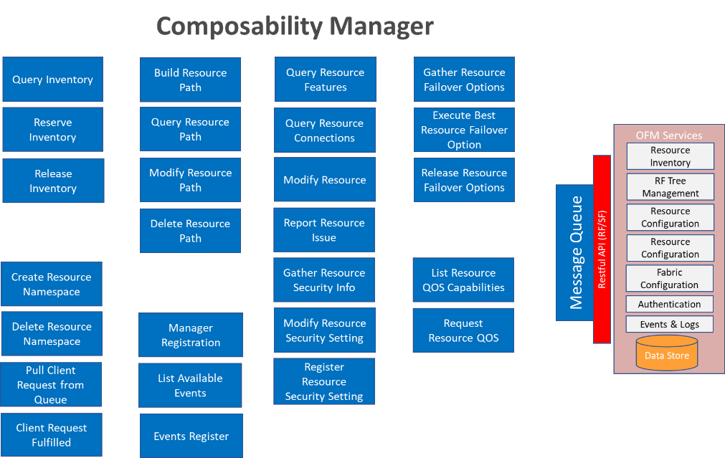
See accompanying PowerPoint deck for editable version
---
Register Manager
Inputs: Register/Unregister flag, Manager ID, Access capabilities, Security key
Outputs: Status
List Available Events
Inputs Manager ID, Security Key, Event Types (All, …)
Outputs: Status, List of events
Events Register
Inputs: Register/Unregister flag, Manager ID, Security Key, Event Type (All / …) OR List of Events
Outputs: Status
List Resource QOS Capabilities
Inputs: Manager ID, Security Key, Resource ID
Outputs: Status, List Resource Capabilities
Request Resource QOS
Inputs: Manager ID, Security Key, Resource ID, QOS Option
Outputs: Status
Gather Resource Failover Options
Inputs: Manager ID, Security Key, Resource ID
Outputs: Status, List of Failover Options
Release Resource Failover option
Inputs: Manager ID, Security Key, Resource ID, Failover Option
Outputs: Status
Execute Best Resource Failover Option
Inputs: Manager ID, Security Key, Resource ID, Scope
Outputs: Status
Query Resource Features
Inputs: Manager ID, Security Key, Resource ID, Resource type (All, location, speed, manufacturer, …)
Outputs: Status, Resource ID, List of Resource Features
Query Resource Connections
Inputs: Manager ID, Security Key, Resource ID
Outputs: Status, Resource ID, List of Resource Connections
Query Resource Path
Inputs: Manager ID, Security Key, Resource ID
Outputs: Status, Resource ID, List of Resource Paths
Build Resource Path
Inputs: Manager ID, Security Key, Resource ID, Path
Outputs: Status
Modify Resource Path
Inputs: Manager ID, Security Key, Resource ID, Path ID, Path
Outputs: Status
Delete Resource Path
Inputs: Manager ID, Security Key, Path ID
Outputs: Status
Modify Resource
Inputs: Manager ID, Security Key, Resource ID, Resource Characteristic tuple
Output: Status
Create Resource Namespace
Inputs: Manager ID, Security Key, Resource ID, Namespace ID, Initial ACL, Allowed Client List
Outputs: Status
Delete Resource Namespace
Inputs: Manager ID, Security Key, Resource ID, Namespace ID
Outputs: Status
Query Inventory
Inputs: Manager ID, Security Key, Resource Type (All, Memory, Storage, CPU, …)
Outputs: Status, List of Resources
Reserve Inventory
Inputs: Manager ID, Security Key, Requested Resource ID list
Outputs: Status, List of Reserved Inventory IDs
Release Inventory
Inputs: Manager ID, Security Key, Released Resources <All/Resource Type, Resource ID list>
Outputs: Status
Report Resource Issue
Inputs: Manager ID, Security Key, Resource ID, Issue
Outputs: Status
Gather Resource Security Info
Inputs: Manager ID, Security Key, Resource ID
Outputs: Status, Resource ID, Resource Security Status (Unsecure, Restricted), <Allowed Client List>
Modify Resource Security Setting
Inputs: Manager ID, Security Key, Class / Resource ID, Access Type <Unsecure, Restricted>, Restricted List>
Outputs: Status
Register Resource Security Setting (Mike understands this one – up to him to explain)
Inputs: <>
Pull Client Request from Queue
Inputs: Manager ID, Security Key, Queue ID
Output: Status, Client Request
Client Request Fulfilled
Inputs: Manager ID, Security Key, Queue ID, Request ID, Request Status
Outputs: Status

